**eRoof**

**Software Design**

May, 2010

**eRoof Asset Management System**

TABLE OF CONTENTS

1 Introduction 4

1.1 Menus 4

1.2 Menu and tab details 4

1.3 Reports 5

2 UI Components 6

2.1 Mapping 6

2.2 UI Controls 9

3 Developer 10

3.1 Database 10

3.2 Test UI – Forms 10

3.3 Test UI - Grids 10

4 Admin 11

4.1 Business setup 11

4.2 Preferences 11

4.3 Report Library 12

4.4 Roles 12

4.5 Users 13

4.6 Virtual Assistant 13

5 Facilities 14

5.1 Purpose 14

5.2 Design Concepts 14

5.3 Navigation tree 15

5.4 Add procedure 16

5.5 Business Folders 17

5.6 Segment Folders 18

5.7 Client Folders 19

5.8 Facility Folders 20

5.9 Section Folders 22

6 Analysis 30

6.1 Sections 30

6.2 Systems 30

6.3 Details 30

6.4 Deficiences 30

6.5 Expenditures 30

6.6 Inspections 30

6.7 Action Items 30

6.8 Warranties 30

7 Tasks 31

7.1 Inspections 31

7.2 Service work 31

7.3 Maintenance 31

7.4 Tendering 31

7.5 Project inspections 31

8 On-roof data inspections 32

8.1 Data capture 32

9 Technical Notes 33

9.1 Location markers 33

9.2 Photo display component 33

10 Notes 35

# Introduction

## Menus

There are 6 main menus in the eRoof application:

* **Developer** – Functions available to developers only.
* **Admin** – Used by the system administrator to enter business configuration, preferences, roles and permissions, and report definitions.
* **Facilities** – Used to view details on specific clients, facilities and roof sections.
* **Analysis** – Used to analyse information across multiple clients and facilities. For example, warranties for all roof sections can be viewed and sorted by date to determine warranties that are about to expire
* **Financial** – Used to view and revise financial data – including repair, maintenance and replacement budgets, and 10 year financial plans.
* **Tasks** – Used to execute tasks available to the current user – such as entering inspection data (an inspector), approving invoices (a consulting), or entering payment details (a client).

Details for each of these menus are provided in the following sections.

## Menu and tab details

Developer

* Database tables
* Test UI - Forms
* Test UI - Grids

Admin

* Business Setup
* Preferences
* Report library
* Roles
* Users
* Virtual Assistant

Facilities

* All Facilities (only one sub-menu)

Business tabs:

* **Summary**
* Segments
* Map

Segment tabs:

* Summary
* Clients
* Map

Client tabs:

* Summary
* Facilities
* Map

Facility tabs:

* **Summary**
* Sections
* Map
* Site Plan
* Details
* Deficiencies
* Inspections
* Expenditures
* Warranties

Section tabs:

* **Summary**
* Site Plan
* Roof Plan
* **System**
* **Core Cuts**
* Details
* Deficiencies
* **Inspections**
* Surveys
* **Expenditures**
* Warranties

Analysis (No sub-menus)

Financial (No sub-menus)

Tasks

* Approve inspections (3)
* Approve service work (5)

## Reports

Reports are integrated into the application and available from selected screens. A printer icon is displayed at the top right of the page when one or more reports are available.

# UI Components

This section describes several components are are used in multiple screens.

## Mapping

This section describes the mapping and drawing functions that are used in various screens.

There are 4 types of maps

* **Multiple facility maps** - Maps that display the location of multiple facilities.
* **Single facility map** - A map that displays the location of a single facility with the immediate neighbourhood.
* **Facility site plan** – using a satelite image.
* **Roof plan** – showing a specific roof.

The user functionality is as follows:

Multiple facility maps

This map is used to display the location of multiple facilities, and is used at the business, segment, and client level. These maps provide the ability to adjust the map positioning and zoom level. Map positions are saved for the business, for each segment and for each client.

The functions are as follows:

* A map is displayed on the summary page.
* The map will be displayed with multiple facility markers.
* There will be no operations available for zoom, pan. Markers clickable for info box display.
* A full screen display will be requested through double click.
* The full screen map will display over the previous screen, and display as a modal window.
* There will be an **Exit** button to return to the Summary page.
* The full screen will also have clickable markers - Facility name, Address, City, Province - but not pan and zoom.
* There will be an optional **Edit** button – available based on the user’s permissions.
* The Edit function will enable zoom and pan, and display **Save** and **Cancel** buttons.
* When **Save** or **Cancel** is clicked, the previous screen will be displayed.
* The user will click **Exit** to return to the Summary page.
* The smaller map display on the summary should display the same content as the full screen map.
* Logic required to calculate the zoomlevel for the smaller map.
* Facility markers that have not been set by the user will not display.

Single facility map

This map is used to show a facility location within the neighbourhood – basically a driving map. The functions are the same as the multiple facility maps, except:

* Displays only one marker – for the facility.
* The edit function will also allow repositioning of the marker.
* The same Edit function will move the marker and set the map pan and zoom.
* There will be a “Create facility marker” button. If the marker has been previously created, it will be moved to the center. It will not be possible to create 2 markers.
* The Save function will save the marker position as well as the position and zoom.
* No requirement to remove a marker.

Site Plan

This map shows the site plan using a satelite image, and may also shown the roof section polygons. Unlike the above map displays, the user may select which layers are to be displayed. This will be done as check boxes on the summary page, which will then be applied to the display on both the summary page and the full screen display.

The site plan is display on the facility summary page and the section summary page. On the section summary page, the current roof section is highlighted.

The functions are as follows:

* A site plan is displayed on the summary page.
* Checkboxes will be displayed below the map for Map [ ] Satelite [ ] Drawing [ ]
* This display selection will be a “UI” setting that will affect all facility site plan displays – not just the current site plan.
* The default will be Map [ ] Satelite [ x] Drawing [x]
* The facility marker will not be displayed. There are no info boxes.
* There will be no operations available for zoom, pan.
* There will be a full screen display, with the **Edit** and **Exit** buttons as in above map displays.
* The full screen display will apply the same layer settings. The mapping component does not require a layer selection control. It is in the calling screen only – which sets the properties for the component to control which layers are displayed.
* The Edit function will be used to revise the position and zoom, as in prev screens.

The facility site plan will be available from both the facility summary page and the section page. When it is displayed from the section page, the current section will be shaded.

Roof Plan

A roof plan displays an individual roof section using a satelite image and polygon. As with the site plan, the user will be able to select the layers that are displayed. This selection will also be a UI selection that will affect all roof plan displays, not just the current roof plan.

The UI selection for the roof plan will be separate from the UI selection for the site plan.

The roof plan edit function will also include the drawing tools to create and edit one or more polygons for the roof section.

The functions are the same as the site plan, with the addition of the drawing functions

* The full screen display will contain the optional **Edit** button.
* The edit screen will contain **Create Roof Plan,** **Edit Roof Plan, Save** and **Cancel** buttons
* The first 2 will be toggle buttons that will show if the tool is in use.
* Pan and zoom should not be available during the Create Drawing and Edit drawing functions.
* The facility marker will not be displayed.

**Component specs**

Database design (information required from Affilia):

* Consultants.MapCenter
* Consultants.MapZoom
* Consultants.MapBound
* Segment.MapCenter
* Segment.MapZoom
* Segment.MapBound
* Client.MapCenter
* Client.MapZoom
* Client.MapBound
* Facility.MapCenter
* Facility.MapZoom
* Facility,MapBound
* Facility.SiteplanCenter
* Facility.SitePlanZoom
* Facility.SitePlanBound
* Facility.Position – The facility
* Section.MapCenter
* Section.MapZoom
* Section.MapBound
* Section.RoofPlanCenter
* Section.RoofPlanZoom
* Section.RoofPlanBound
* Section.Polygons

Component properties

* TabName – “Business”, “Segment”, “Client”, “Facility”, “Section” – will control the source of marker locations and info box information.
* MapType – “Multi”, “Single”, “SitePlan”, “RoofPlan”
* Map – true if map layer is to be displayed.
* Satelite – true if satelite layer is to be displayed.
* Drawing – true if drawing is to be displayed
* ShowSection – true if the current section is to be shaded.
* AllowEdit – true if the Edit function is allowed.
* AllowDraw – true if the Edit form is to include the drawing tools.

|  |  |  |  |  |  |  |  |
| --- | --- | --- | --- | --- | --- | --- | --- |
| **TabName** | **MapType** | **Map** | **Satelite** | **Drawing** | **ShowSection** | **AllowEdit** | **AllowDraw** |
| Business | Mult | True | False | False |  | True |  |
| Segment | Mult | True | False | False |  | True |  |
| Client | Mult | True | False | False |  | True |  |
| Facility | Single | True | False | False |  | True |  |
| Facility | SitePlan | From UI | From UI | From UI |  | True |  |
| Section | SitePlan | From UI | From UI | From UI | True | True |  |
| Section | RoofPlan | From UI | From UI | From UI |  | True | True |

## UI Controls

# Developer

## Database

* Developer Grids to view/ edit database content
* Tree with table names on left side.

## Test UI – Forms

## Test UI - Grids

# Admin

The Admin menu provides functions used to perform administrative tasks that are available to the current user.

There are 6 sub-menus, as follows.

## Business setup

This is a form to be used by subscribers to define the business name, a logo for report title pages, and contact information. The system will support operation under several business names; therefore, this form should provide the ability to edit multiple consultant records.

*Note – We will need to revise the tree to support multiple Consultant records. This is not required now – it will be defined as a future task.*

Functions:

* Left side - display a list of all consultants – with consultant names, sorted.
* Right side – display a view form with Edit functions as as in our test UI.
* The fields are:
  + Business name – “Aegis Building Sciences”
  + Contact - “Alistair Wilson”
  + TitlePageAddress - Memo
  + Logo (image upload)
* Add and delete functions are not required in this release – records will be added using Quickbase table maintenance.

## Preferences

* To be determined.

## Report Library

The report library is used to define reports that may be printed and/or saved. The following information is entered for each report.

* Report Name – A report name of up to 20 characters. Duplicate report names are allowed, since different reports may be assigned to different roles. The same report name may also be used from different menu locations.
* Permitted Roles – A multiple-select field that defines which roles may use the report.
* Screen name – A screen name where the report is available, in the format Menu.SubMenu.Level.Tab – for example Facilities..Facility.Summary
* Definition – The definition tags in a memo field.

All reports are listed in a grid – with the report name, permitted roles and screen name.

* Add Report - Prompt for a report name.
* Edit – Edit all 4 fields in form.

No validation is required.

## Roles

The application contains 5 standard roles.

* Admin – System administrator, with access to access menus, forms and fields.
* Consultant – A consultant with access to assigned clients.
* Inspector – An inspector with limited access to selected roof sections.
* Client – A client with limited access to their information.
* Contractor – A contractor has limited access to selected facilities.

The following information may be defined for each role.

* The menu items available.
* The facilities tree levels available.
* The analysis functions available.
* The specific fields that are viewable and editable.
* The specific database content that is available (see next section)

## Users

A tabbed dialog box is displayed with 3 pages – Client Access, Facility Access, and Section Access.

Each form display a list of the current access rights, with add, edit, delete functions

* Client Access - list of client names and users.
* Facility Access – list of client name, facility name, users
* Section Access – list of client name, facility name, designation, users.

No validation is required.

## Virtual Assistant

# Facilities

Misc Notes

* On application start-up, the map displays as full screen before resizing into the form?

## Purpose

* Used to view information on specific clients, facilities and roof sections, plus summary information at the segment and business levels.

## Design Concepts

Summary tabs

The first tab for each level is a summary tab that provides information on the selected item.

* Business – Summary stats and map.
* Segment – Summary stats and map.
* Client – Client address and contact information, client logo, head office photo, map.
* Facility – Facility name, address, contact information, facility photo, map location, site plan and other summary information.
* Section – Designation, roof name, size, year installed and other summary information

List tabs

The second tab lists the “child records” with summary information, providing sorting and searching functions

Lists

* Business – A list of segments with total # of clients, etc.
* Segment – A list of clients
* Client – A list of facilities
* Facility – A list of roof sections

Functions

* Display all records – no paging.
* Column sorts.
* Find on a sort column.
* Double click to go to the child and display the detail form, with an edit option.
* In-place editing

Maps

* Used to display facility locations with visual navigation.
* Maps always indicate an exact facility location – not the geocoded address.
* Use markers as in google (in place of house icons) – yellow fill.
* Remove the Microsoft Road aerial Hybrid selections (these will be fixed – and not user selectable)
* Can buttons, such as Save Map, overlay the map content, rather than create a blank line?
* We should have logic to ensure that all locations are displayed within the user-defined map.

Site plans

* Satelite images that display site plans and roof plans.

## Navigation tree

Admin and Consultant roles

* Business🡪Segments 🡪Clients 🡪Facilities 🡪 Sections.

Clients, Inspectors and Contractors roles

* Clients 🡪Facilities 🡪 Sections.

Notes

* All nodes should be sorted.
* Icons not required.
* Section nodes should display Designation.
* Nodes should not be expanded by clicking on the name – only on the arrow prefix.

Future (depending on time required)

* Support for client regions.
* Addititional structures
  + Not showing the business and segment levels.
* Active account concept.
* Expand All / Contract All for the selected level.

## Add procedure

An add button is displayed above the navigation tree, to add one or more child records. The button display is based on the currently selected tree level:

* Business selected 🡪 Add a segment.
* A segment is selected 🡪 Add a client.
* A client is selected 🡪 Add a facility.
* A facility is selected 🡪 Add a section.
* A section is selected 🡪 Not displayed.

The following input forms are displayed.

Add Segment

* Segment Name – required, must be unique

Add Client

* Client Name – required, must be unique across all segments
* Brief name – required, must be unique across all segments
* Address
* City
* Province – select list, default ON
* Postal Code
* Country – default Canada

Add Facility

* Facility Name – required, must be unique within client.
* Brief Name – required, must be unique within client.
* Address
* City
* Province – select list, default ON
* Postal Code
* Country – default Canada

Add Section

* Designation – required, must be unique with the facility.
* Roof name

Notes

* Input form will have the basic fields only that are required to create a record. Additional values are entering using the Edit function.
* The input forms are displayed on the left side of the screen – over the navigation tree – as a modal pop-up, with Save and Cancel options.
* After a record is added, the tree is re-displayed, and the tree node for the added record is displayed. The summary tab for the added record should be selected, allowing the user to immediate click on Edit to enter additional information for the added record, if required.

## Business Folders

* Display information on the overall business, with summary information for each segment.
* Heading “Business Summary: Aegis Building Sciences”

Summary tab

**Aegis Building Sciences Inc**.

Oakville Ontario

Total # of clients = 99

Total # of facilities = 770

Total # of sections = 2,000

Total Sq. Ft = 1,200,000

Total Est Asset Value = $ 12,333,444

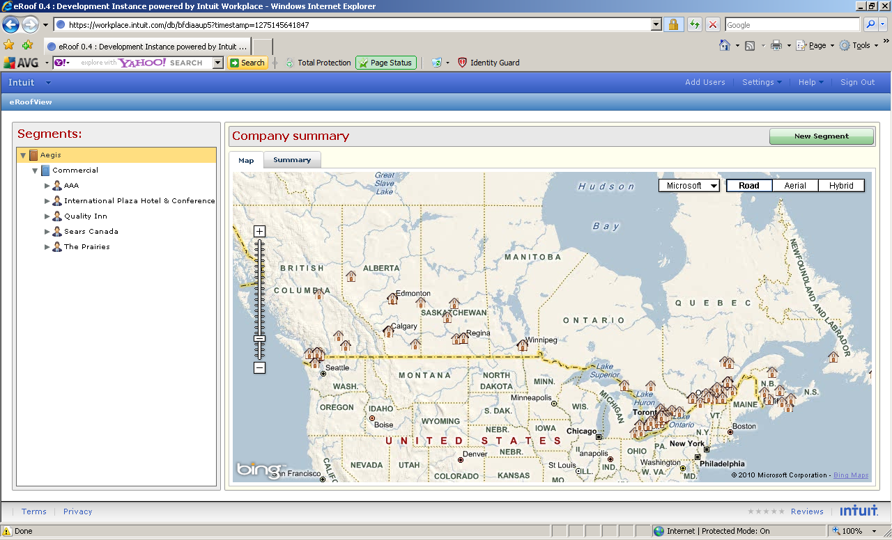

* **No Edit button – will be in admin menu.**
* Standard “multiple facility” map control.

Segments tab

* A list of all segments with totals, as below:
* Column sorts.
* Inplace cell edit on segment name.
* Column totals at bottom.

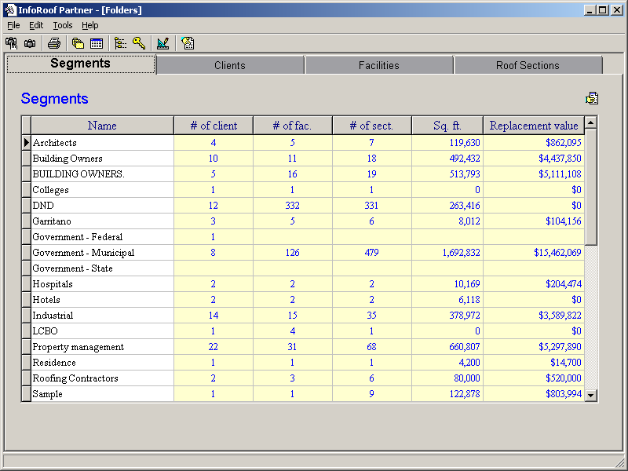

Est Value

## Segment Folders

* Displays summary information on a selected segment – with summary information on the clients within the segment.
* Heading “Commercial Segment Summary”

Summary tab



**Commercial Segment**

Total # of clients = 99

Total # of facilities = 770

Total # of sections = 2,000

Total Sq. Ft = 1,200,000

Total Est Asset Value = $ 12,333,444

* No Edit function.
* Standard “multiple facility” map control.

.

Clients tab

* List of clients, as below
* Column sorts.
* User filters – based on value selection for a single column – for example City=Ottawa – Can be coded as required (versus general capability of grids).
* Inplace edit of client name, brief name, address and city – single cell – double click?
* Column totals at bottom.

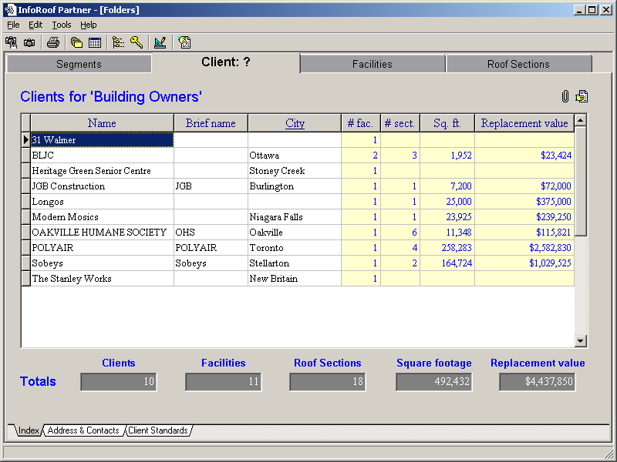

Add Address column

Est Value

## Client Folders

* Display summary information for all facilities for the selected client.
* Heading “Client Summary: Sears Canada”

Summary Tab

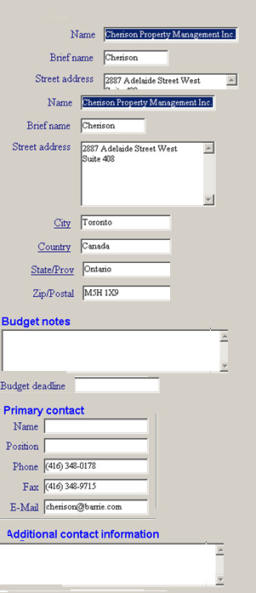

Edit

Logo

* Edit function to revise client information.
* Standard “multiple facility” map control.

Facilities Tab

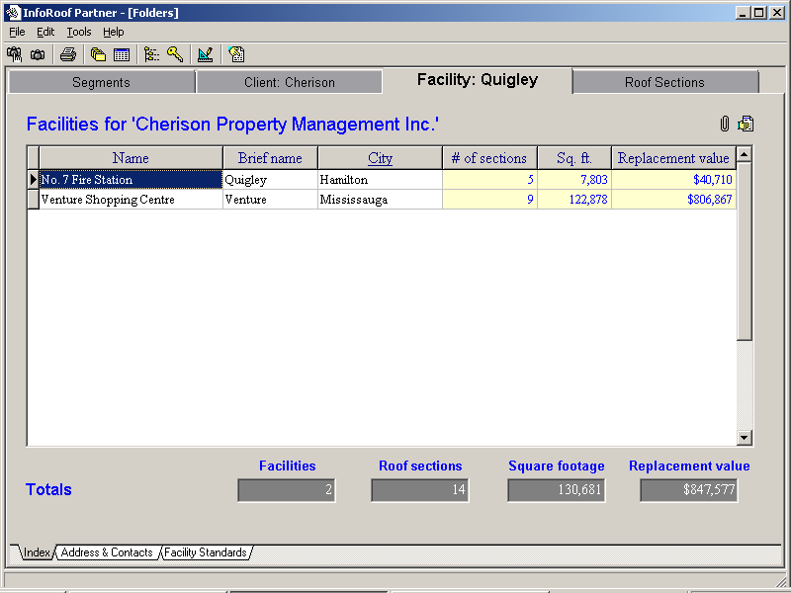

## Facility Folders

* Displays summary information on a selected facility – with summary information on the sections within the facility.
* Heading “Facilty: No 7 Fire Station (Sample Client)”

Summary Tab

All fields from the Facilities table:

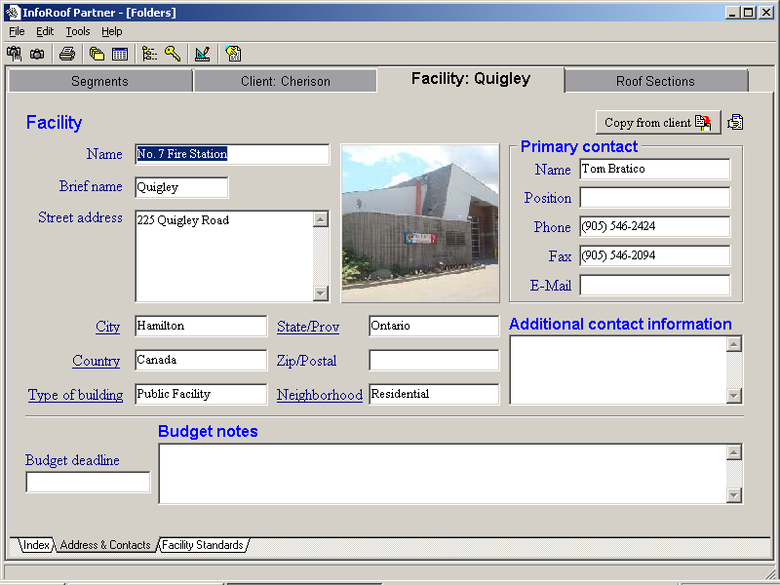

Map [ ] Satelite [ ] Drawing [ ]

Site Plan

Facility Map

Budget Deadline

Budget Notes

Photo

Additional Contacts

Primary Contact

Position

Phone

Cell (New field)

Fax

EMail

Photo

Province

Postal Code

Neighbourhood

City

Country

Type of Building

Facility Name

Brief Name

Address (memo)

* All data fields arranged vertically in left panel.
* Photo, facility map and site plan along the right side.
* Layer selections are displayed below the site plan.
* Facility marker positioning will be done from the facility map.

Sections

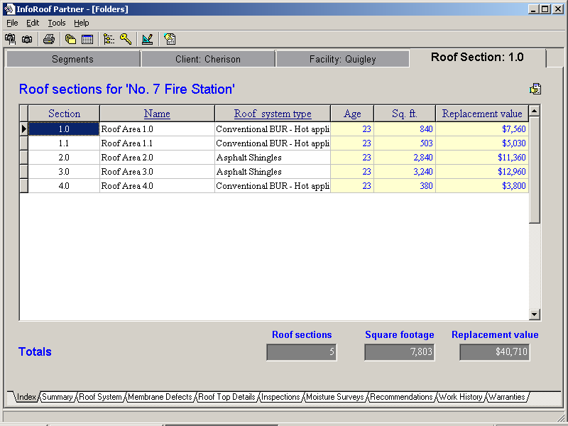

Section Details Tabs

The following tabs provide lists of information that has been entered for the sections at the facility. The tabs contain the same information as the corresponding tabs at the section level, but with a Designation column added as the first column.

* Details
* Deficiences
* Inspections
* Expenditures
* Warranties

## Section Folders

* Displays summary information on a selected segment – with summary information on the clients within the segment.
* Heading: Section 1.0 (Sears Canada – Head Office)

Interior Sensitivity – Text

Condition Index - Text

Restorable – Text

Drainage - Text

Currently Leaking - Text

History of Leaking - Text

Condition Details - Text

Summary tab

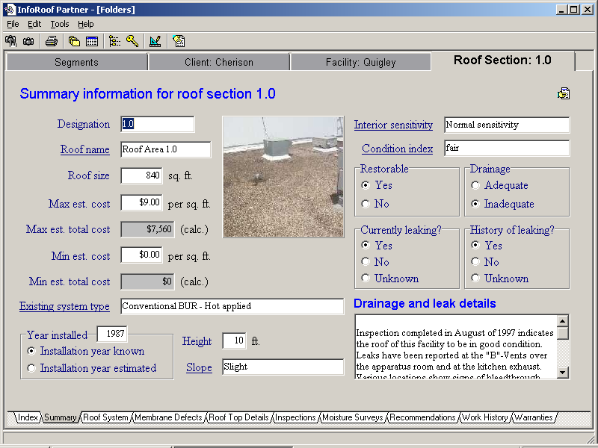

Roof Plan

Map [ ] Satelite [ ] Drawing [ ]

Photo

Site Plan

Roof System

Year Installed

Year Installed Source

Height - Numeric

Slope - Text

Designation – Text

Roof Name - Text

Sq Ft – Numeric

Est Cost per Sq Ft – 2 dec

Est Cost – 0 dec

Min fields

not reqd

Roof Condition Summary

**Reformat to horizontal:**

Known ( ) Estimated ( )

Photo

**Reformat to horizontal:**

Restorable? ( ) Yes ( ) No

Drainage Adequate? ( ) Yes ( ) No

Currently Leaking? ( ) Yes ( ) No ( ) Unknown

History of Leaking ? ( ) Yes ( ) No ( ) Unknown

Map [ ] Satelite [ ] Drawing [ ]

Notes

* All data fields along left side.
* No edits allowed to the site plan – done from the facility tab.
* Roof section highlighted on the site plan.
* Roof plan provides drawing functions.

Roof System tab

Sections.Roof System

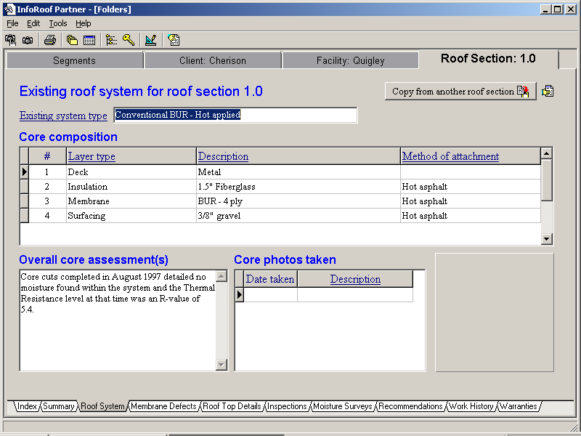

Sections.Overall Core Assessment

(Move to Sections form)

Core Photos.Photo

Core Photos.

Date Description

Layers.

Layer Number Layer Type Description Attachment

* To be split into 2 separate tabs – System and Core Photos
* Overall core assessment to be moved onto the Sections form (end)

Details tab

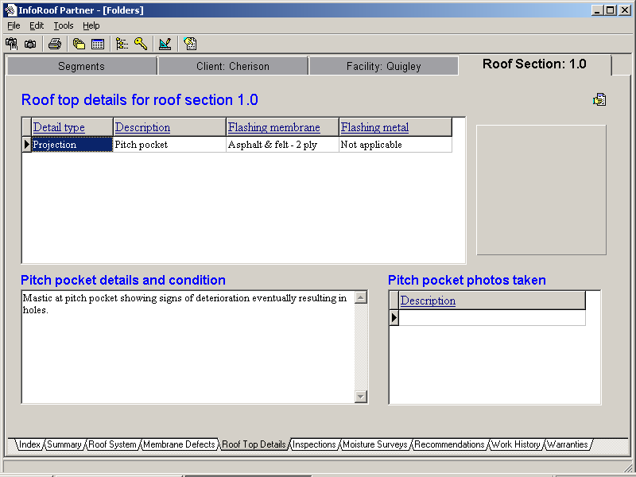

A roofplan/ photo display panel will be displayed on the right side.

Deficiencies tab

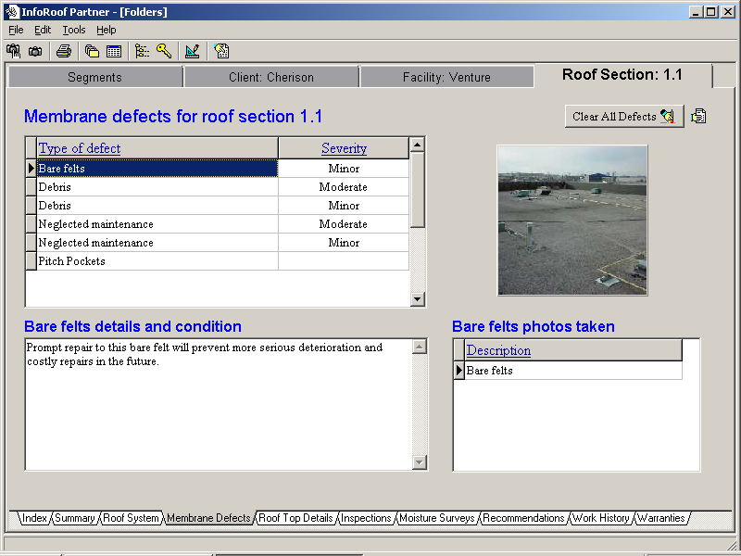

A roofplan/ photo display panel will be displayed on the right side.

Inspections tab

Inspections.

Inspection Date Inspection Type Inspector Company Inspector Name

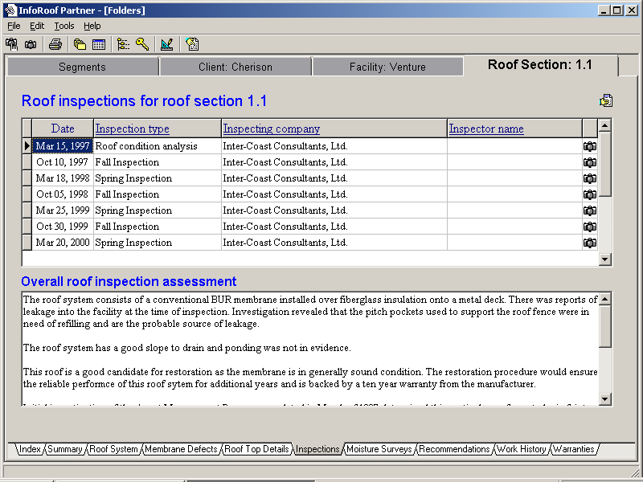

Inspections.Assessment

Moisture Surveys tab

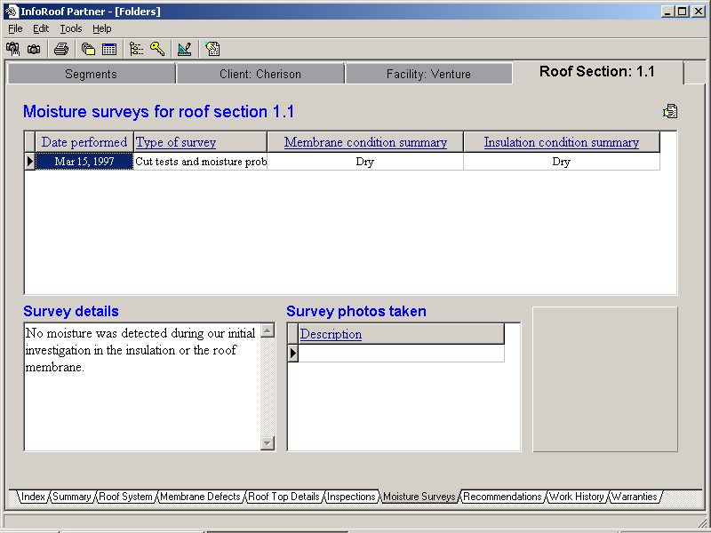

Expenditures tab

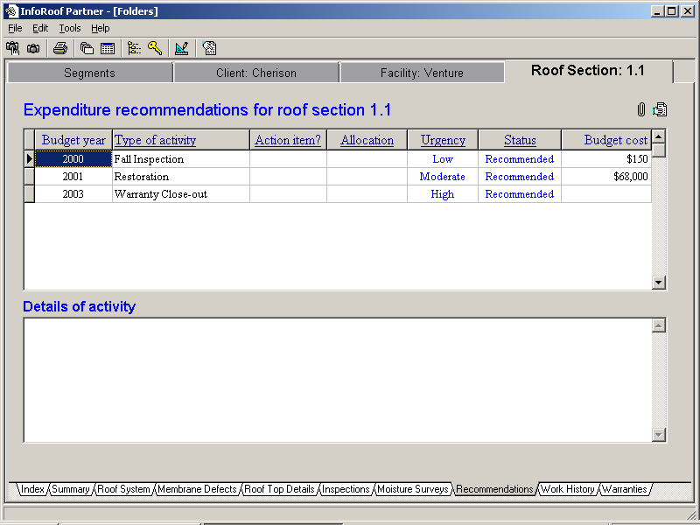

Expenditures.Description

Expenditures.

Budget Year Type of Work Action Item Allocation Urgency Status Amount

Notes

* The expenditures tab will include recommendations only in this release. Work history data (as below) will be added later.

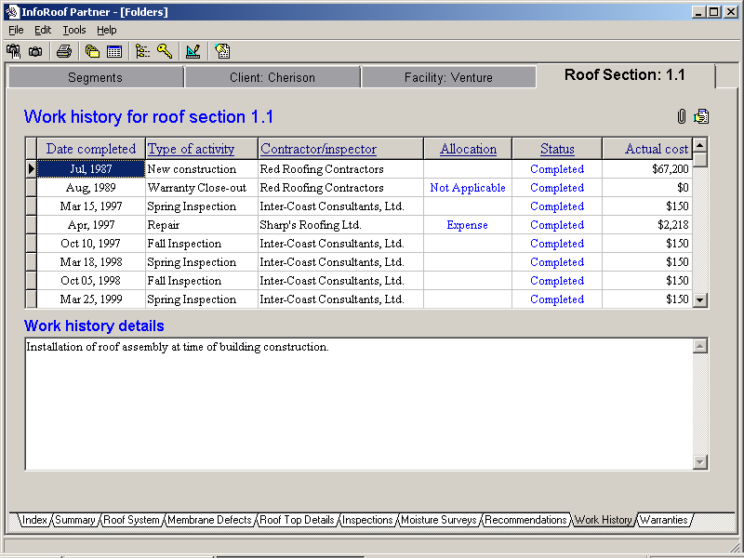

Warranties tab

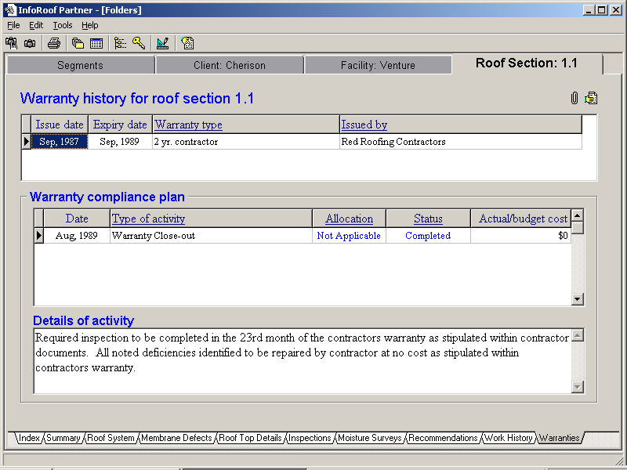

# Analysis

## Sections

* Client
* Facility
* Designation
* Roof System
* Age
* Sq Ft

## Systems

* Client
* Facility
* Designation
* #
* Type
* Description
* Attachment

## Details

## Deficiences

## Expenditures

## Inspections

## Action Items

## Warranties

# Tasks

## Inspections

## Service work

## Maintenance

## Tendering

## Project inspections

771 Golf Links Road

# On-roof data inspections

## Data capture

* Start new form
* Dictate address
* Take photos, enter annotations.

# Technical Notes

## Location markers

## Photo display component

The following screens require multiple photos.

* Roof summary
* Core
* Details
* Deficiencies
* Inspections

These forms require a common component with the following functions

* Display icons on the map at the location of each photo, with the photo number.
* If map location has not been entered, then the icons will be displayed below the picture.
* A Move button will enable icon moving, including moving the icons below the roof plan.
* Clicking on an icon will display the photo and annotation.
* A renumber function is required.

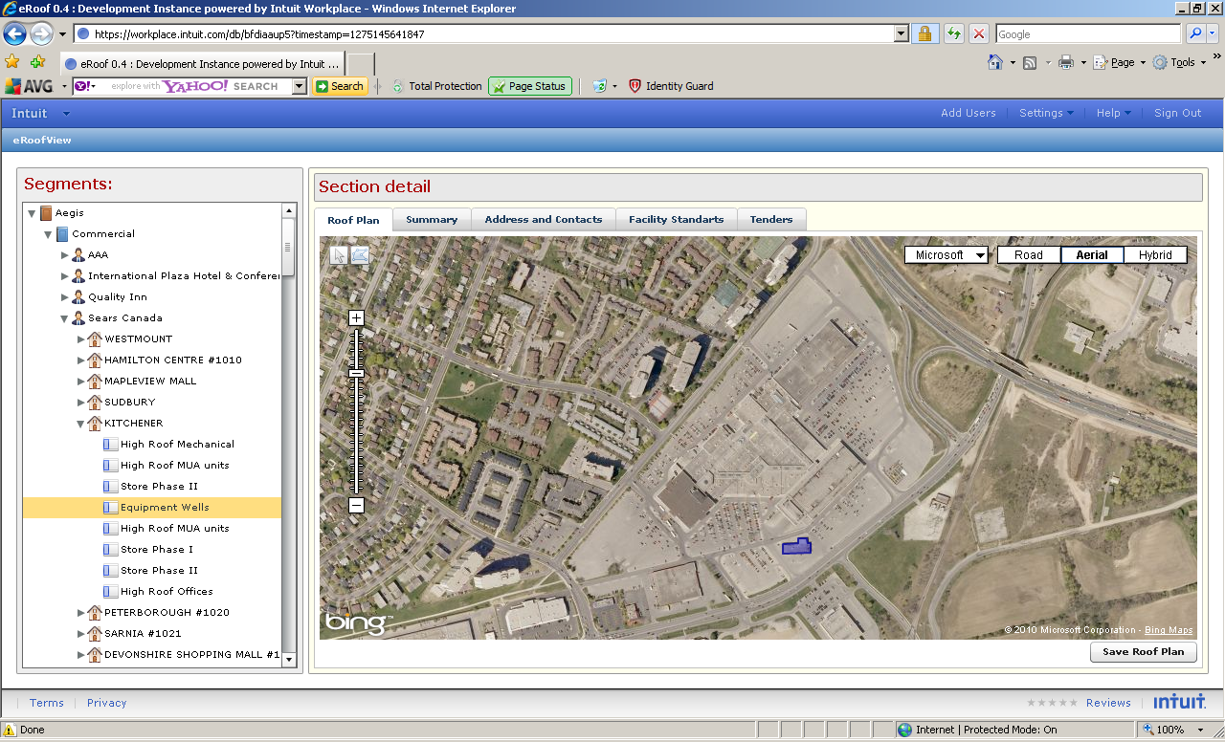

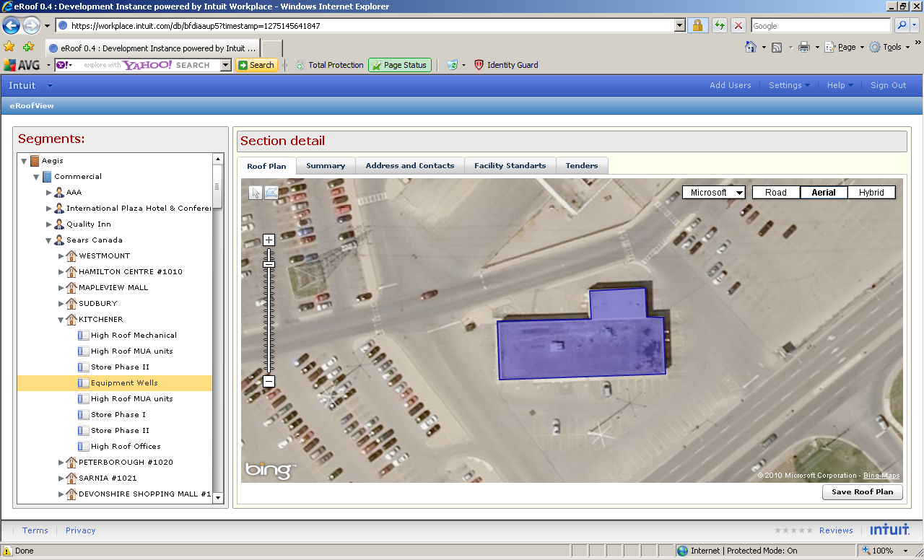

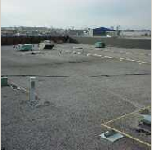

# Notes

Priorities – to drive Affilia work

* Add screens – Segment, Client, Facility, Section.
* Edit screen – Business, Segment, Client, Facility, Section.
* Delete functions.
* All screens.